Test Case: tc001_SPX_Dev5_Crear_Requisicion_Spot_Tipo_Cobro_CC
Step 1 - Enter username and password and click to button Enter : Credentials Entered
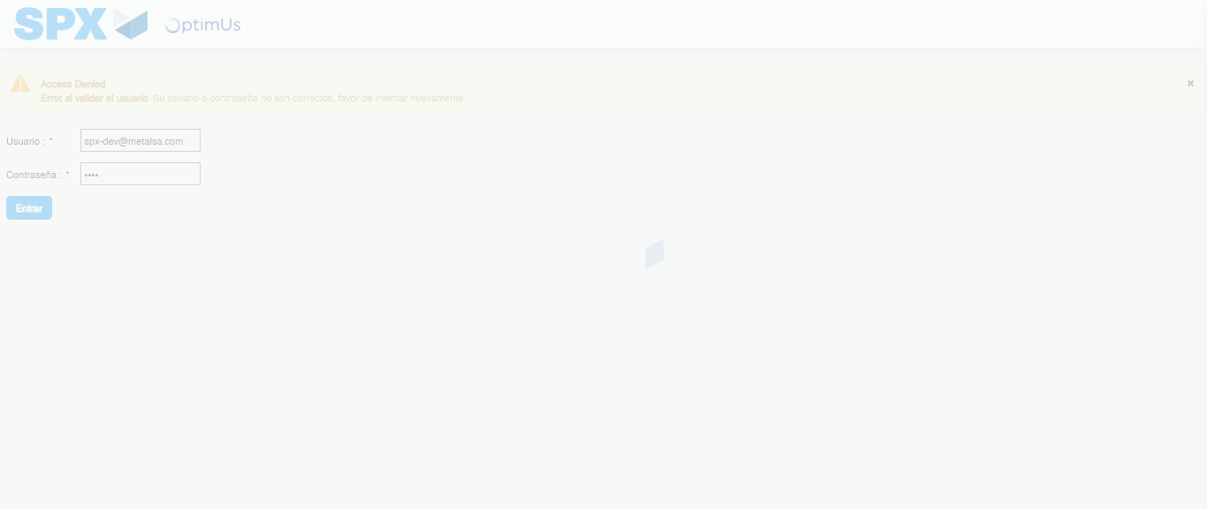Image file-name: QC_Testing-tc001_SPX_Dev5_Crear_Requisicion_Spot_Tipo_Cobro_CC-1788297261206

Step 2 - Select to UEN and Access to Spot Buy Requisitions : UEN Correctly selected and Correct access
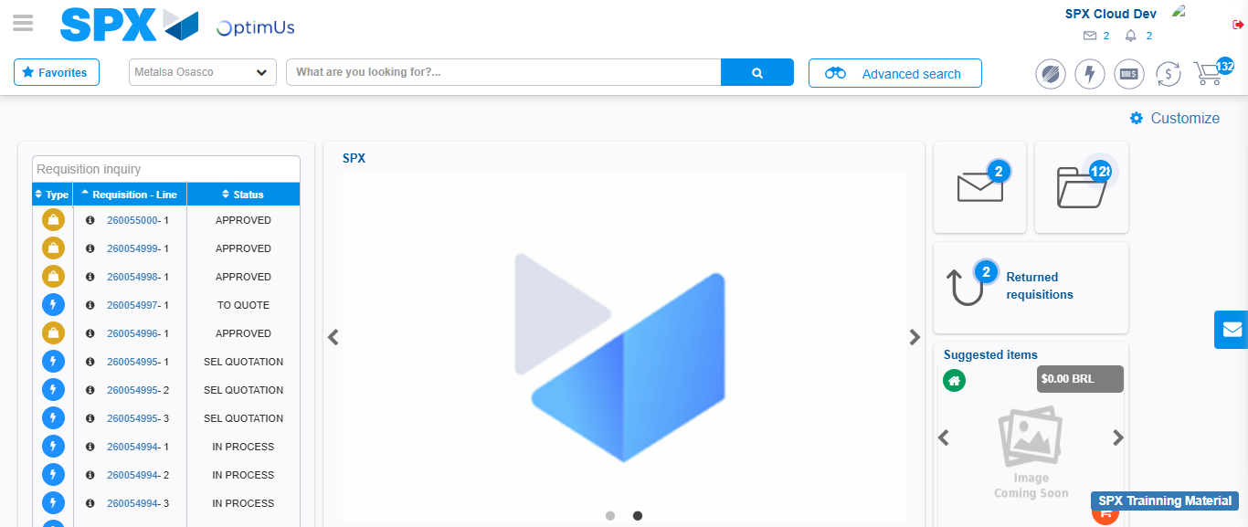Image file-name: QC_Testing-tc001_SPX_Dev5_Crear_Requisicion_Spot_Tipo_Cobro_CC-1788297287145

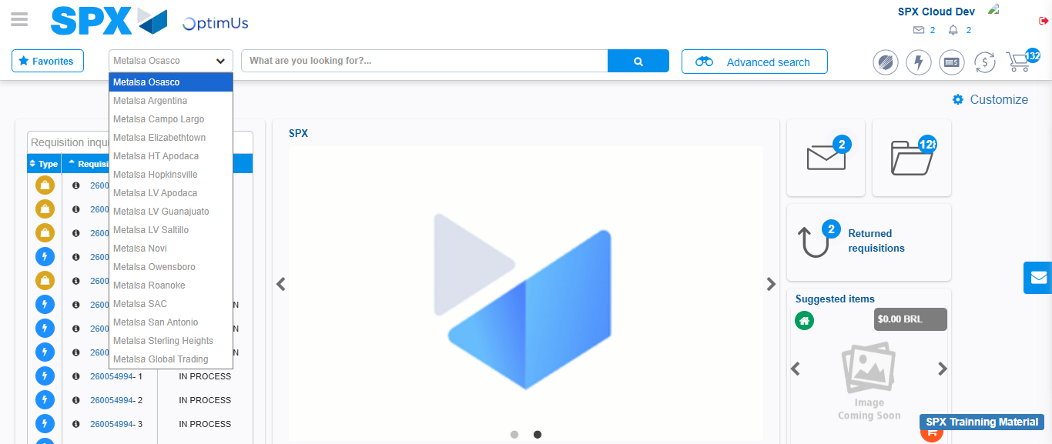Image file-name: QC_Testing-tc001_SPX_Dev5_Crear_Requisicion_Spot_Tipo_Cobro_CC-1788297287589

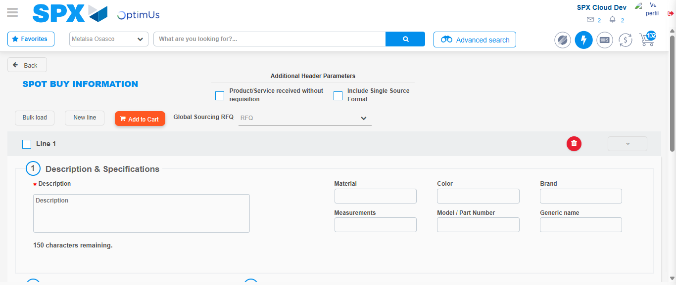Image file-name: QC_Testing-tc001_SPX_Dev5_Crear_Requisicion_Spot_Tipo_Cobro_CC-1788297310122

Step 3 - Data Capture Spot Buy Requisition : Data captured correctly
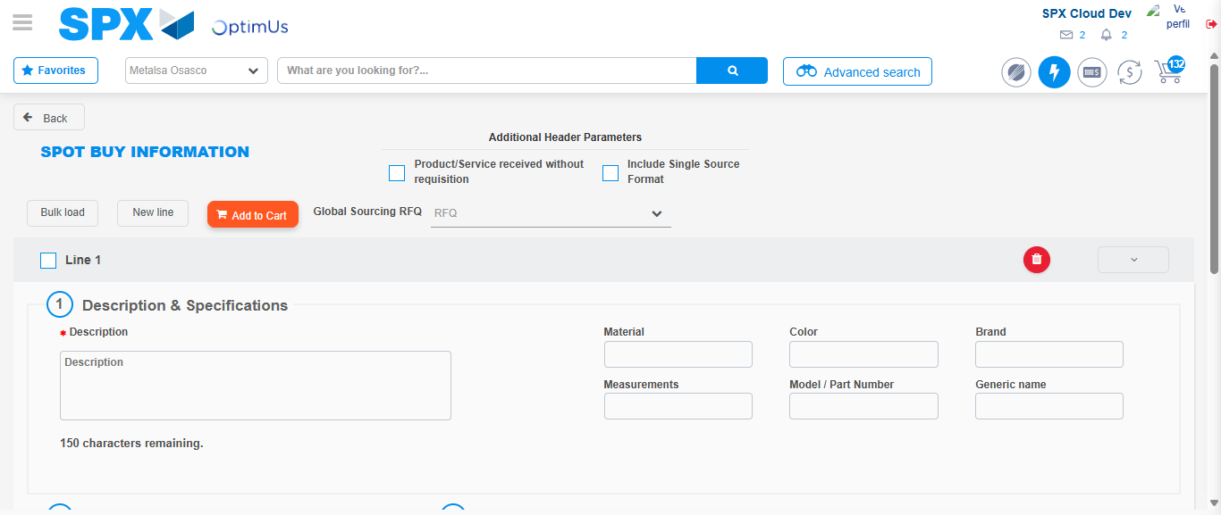Image file-name: QC_Testing-tc001_SPX_Dev5_Crear_Requisicion_Spot_Tipo_Cobro_CC-1788297310373

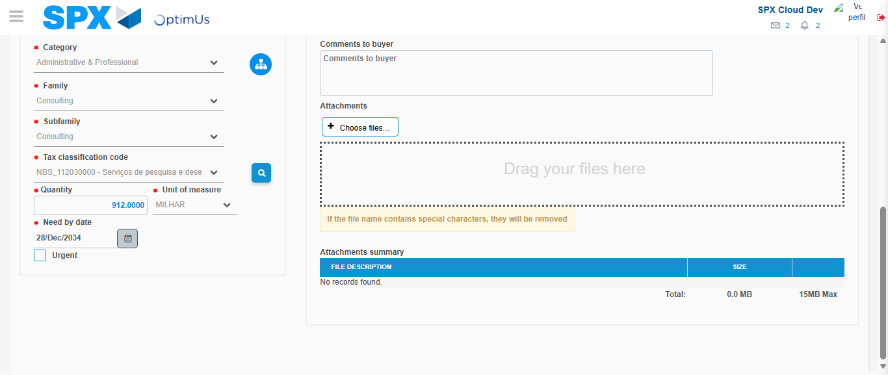Image file-name: QC_Testing-tc001_SPX_Dev5_Crear_Requisicion_Spot_Tipo_Cobro_CC-1788297324778

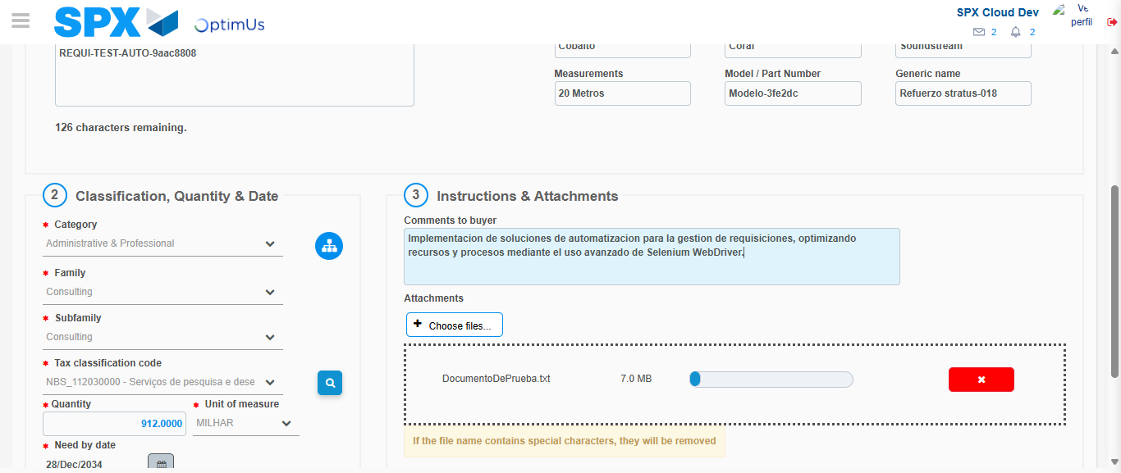Image file-name: QC_Testing-tc001_SPX_Dev5_Crear_Requisicion_Spot_Tipo_Cobro_CC-1788297325507

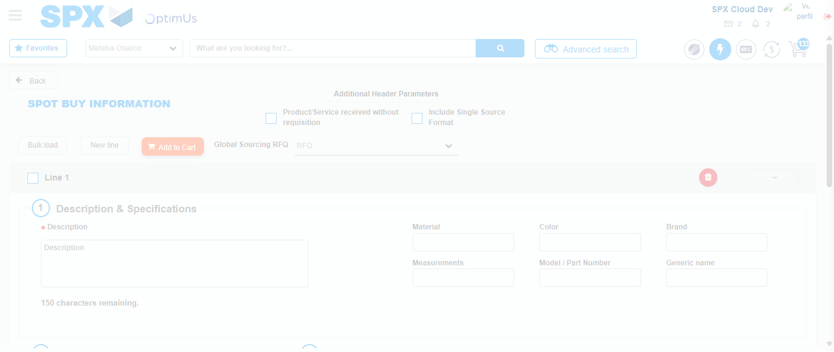Image file-name: QC_Testing-tc001_SPX_Dev5_Crear_Requisicion_Spot_Tipo_Cobro_CC-1788297330504

Step 7 - Return to Main Page SPX : Return to Main Page SPX
Image file-name: QC_Testing-tc001_SPX_Dev5_Crear_Requisicion_Spot_Tipo_Cobro_CC-1788297287145

Image file-name: QC_Testing-tc001_SPX_Dev5_Crear_Requisicion_Spot_Tipo_Cobro_CC-1788297287589

Image file-name: QC_Testing-tc001_SPX_Dev5_Crear_Requisicion_Spot_Tipo_Cobro_CC-1788297310122

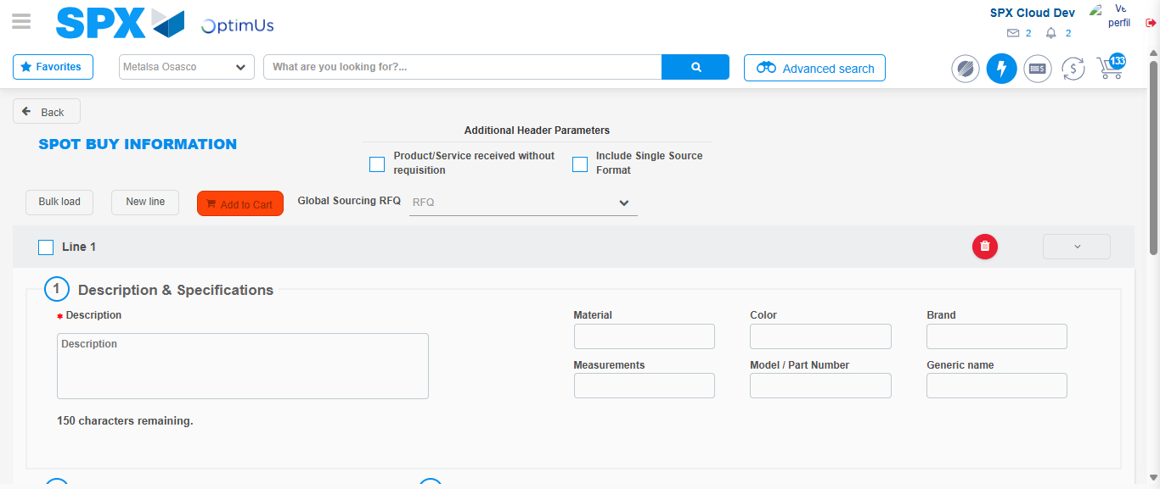Image file-name: QC_Testing-tc001_SPX_Dev5_Crear_Requisicion_Spot_Tipo_Cobro_CC-1788297332713

Image file-name: QC_Testing-tc001_SPX_Dev5_Crear_Requisicion_Spot_Tipo_Cobro_CC-1788297332909

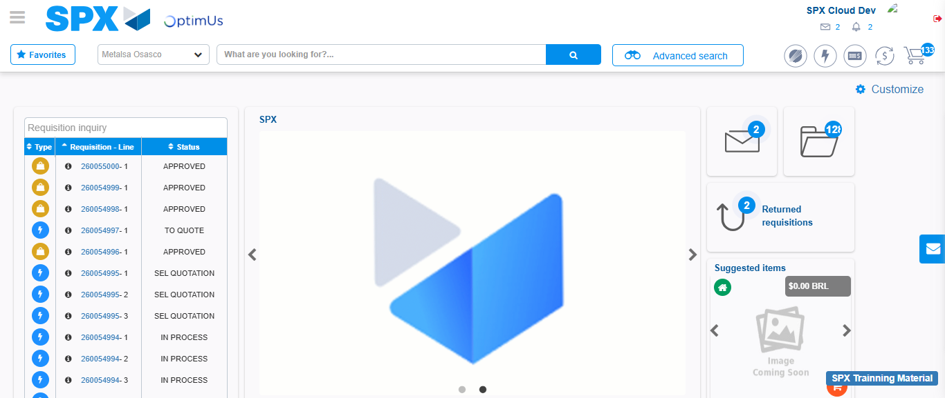Image file-name: QC_Testing-tc001_SPX_Dev5_Crear_Requisicion_Spot_Tipo_Cobro_CC-1788297354055

Step 8 - Log Out : Log Out SPX
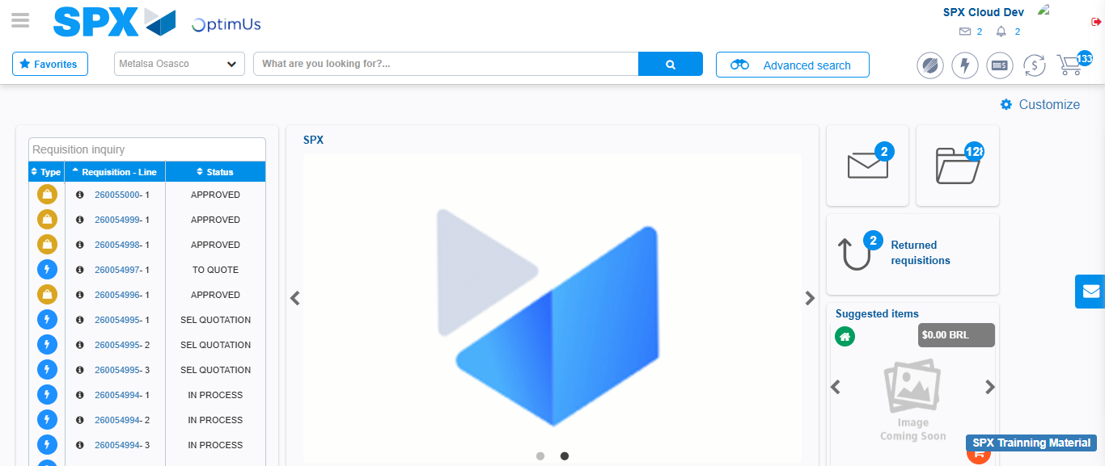Image file-name: QC_Testing-tc001_SPX_Dev5_Crear_Requisicion_Spot_Tipo_Cobro_CC-1788297354399

